**E.1: Practice ﬁnding the derivatives of these functions:**

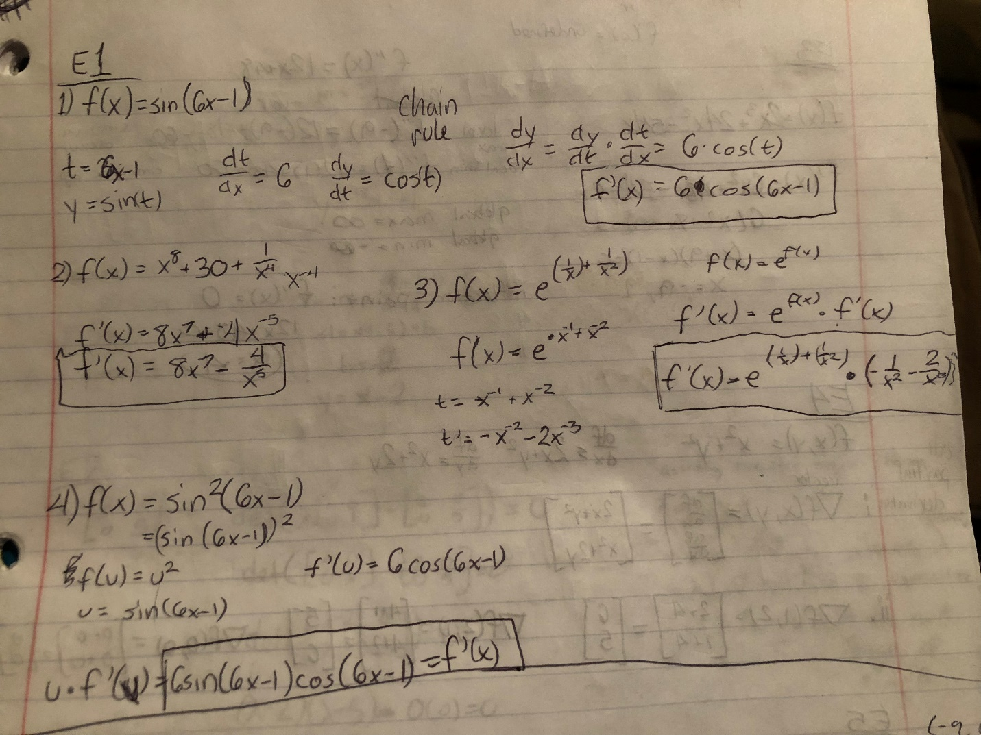

**E.2: Finding when a function is increasing/decreasing and concave up/down. When is the function f(x) = 2x3+24x2−54x decreasing? When is it concave up? Plot the function and ﬁnd your check your answer.**

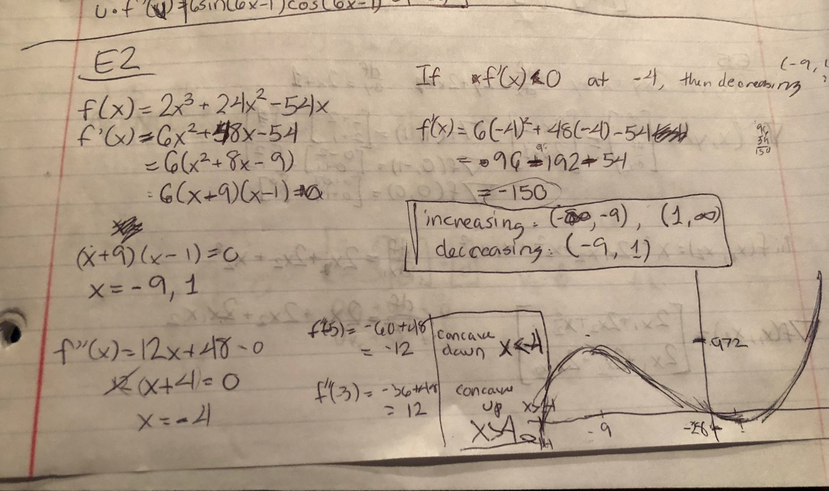

**E.3: Finding critical points, local max/min, global max/min, and inﬂection points. Find all critical points and inﬂection points of f(x) = 2x3+24x2−54x. Classify the critical points as local min, local max, or neither. Find the global max and min of this function on [−3,3] and on (−∞,0). Plot the function and ﬁnd your check your answer?**

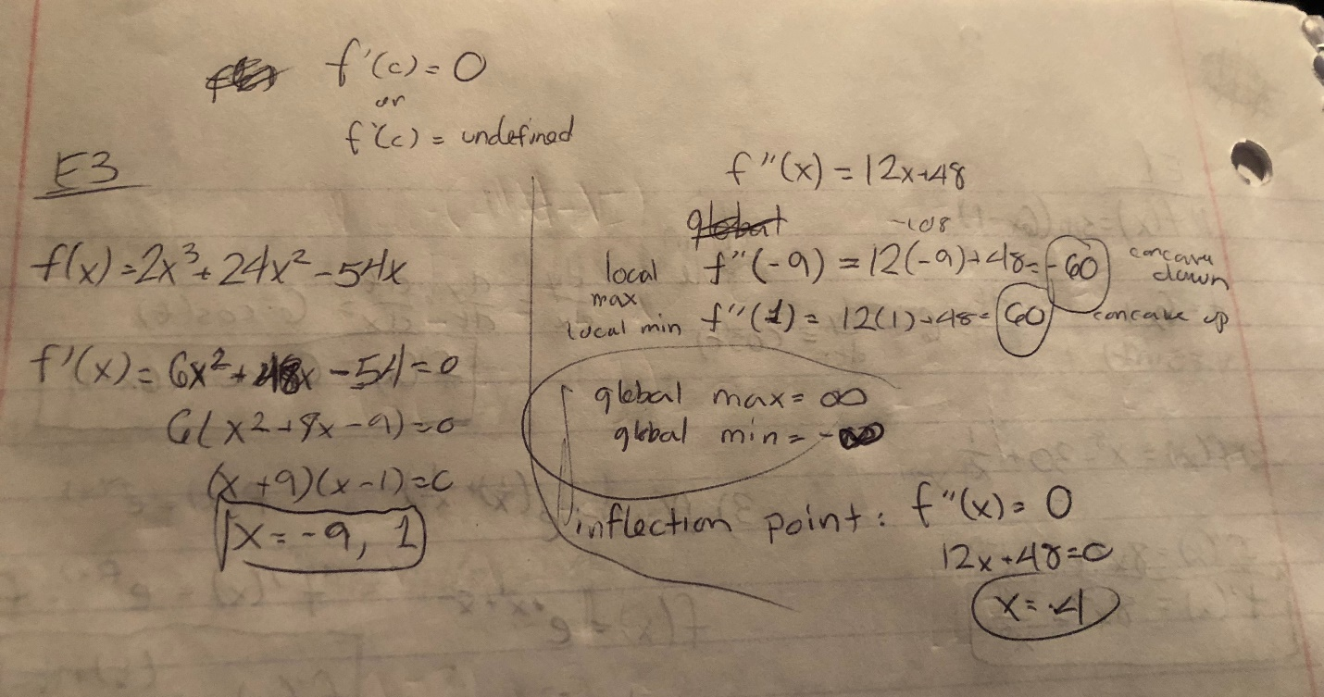

**E.4:**

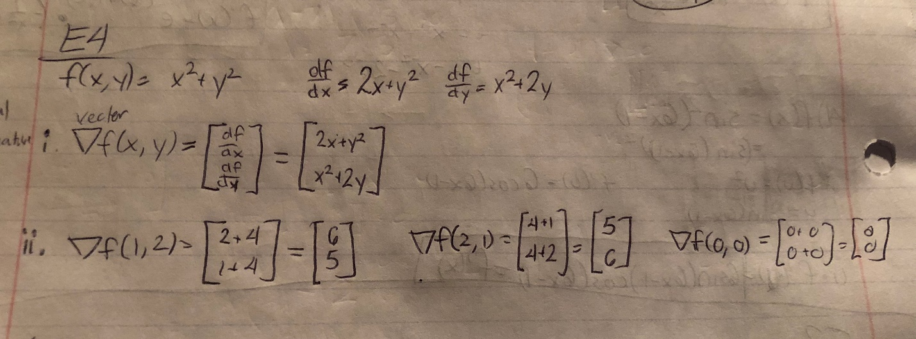

**E.5:**

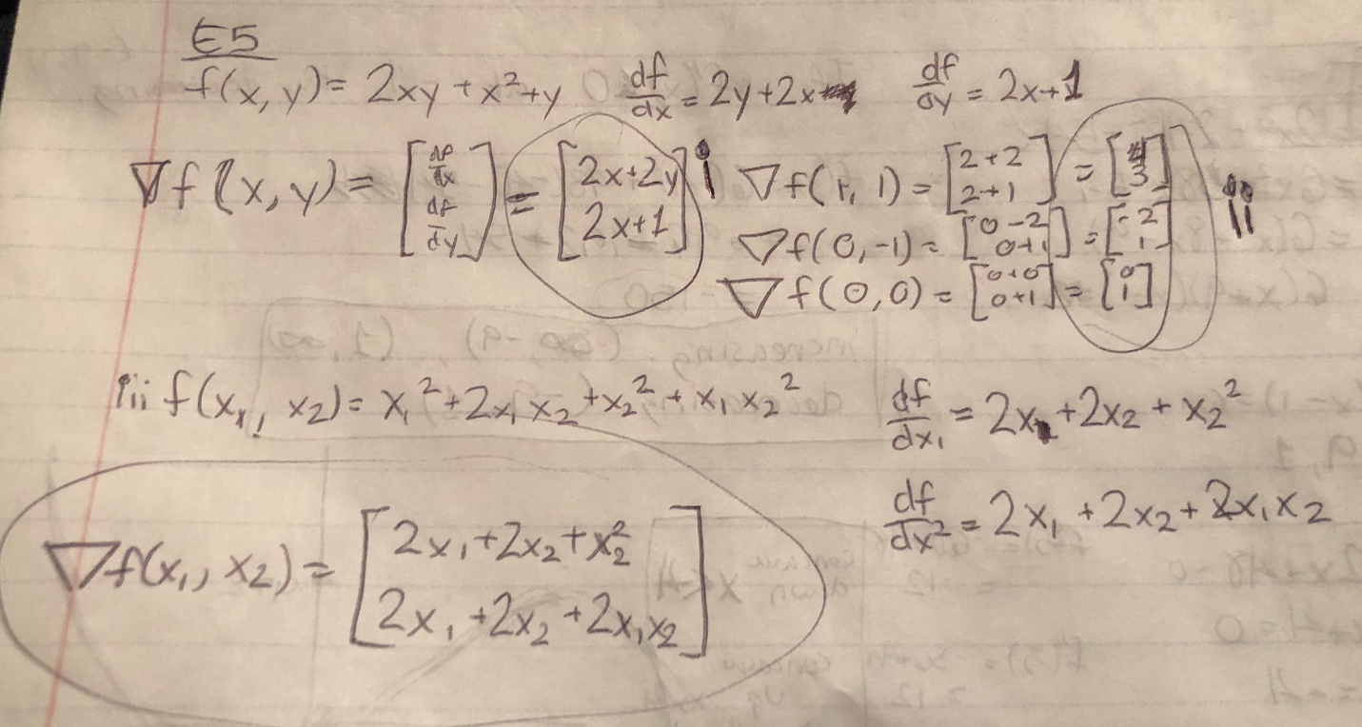

**E.6:**

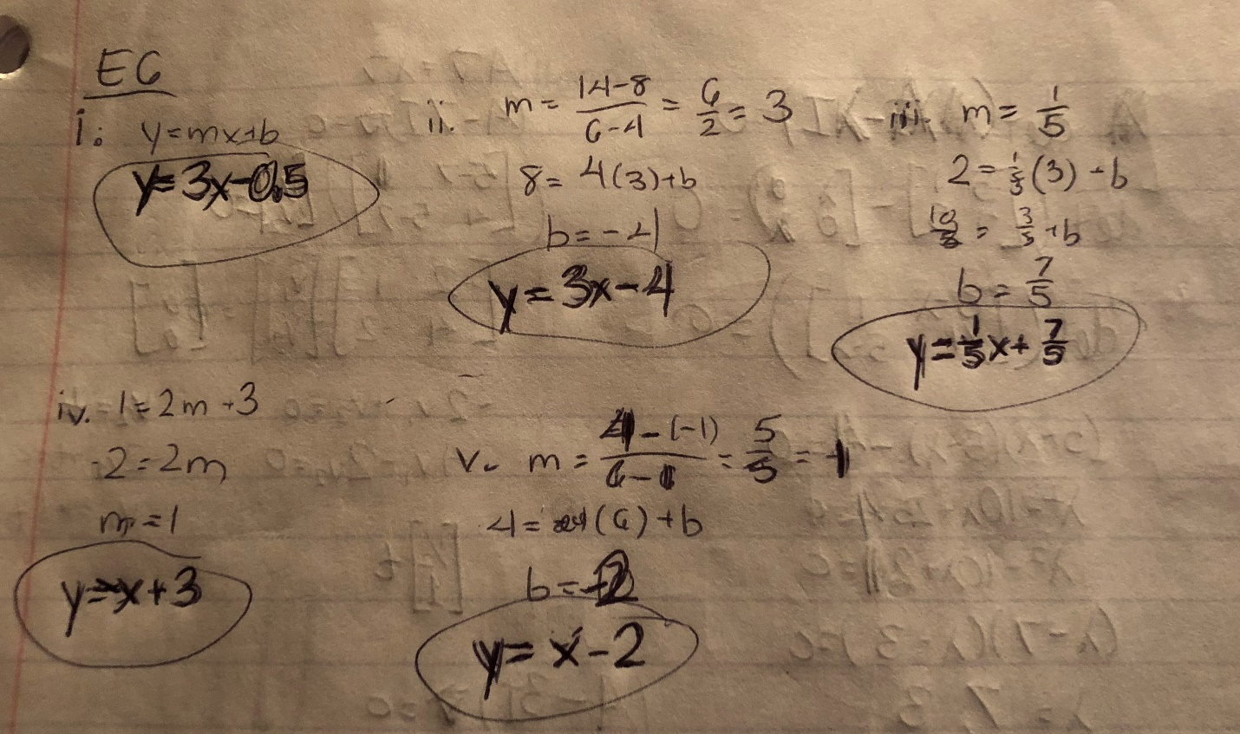

**E.7: Find the eigenvalues and eigenvectors of the given matrix by hand and check results by the computer (use Python to check your results).**

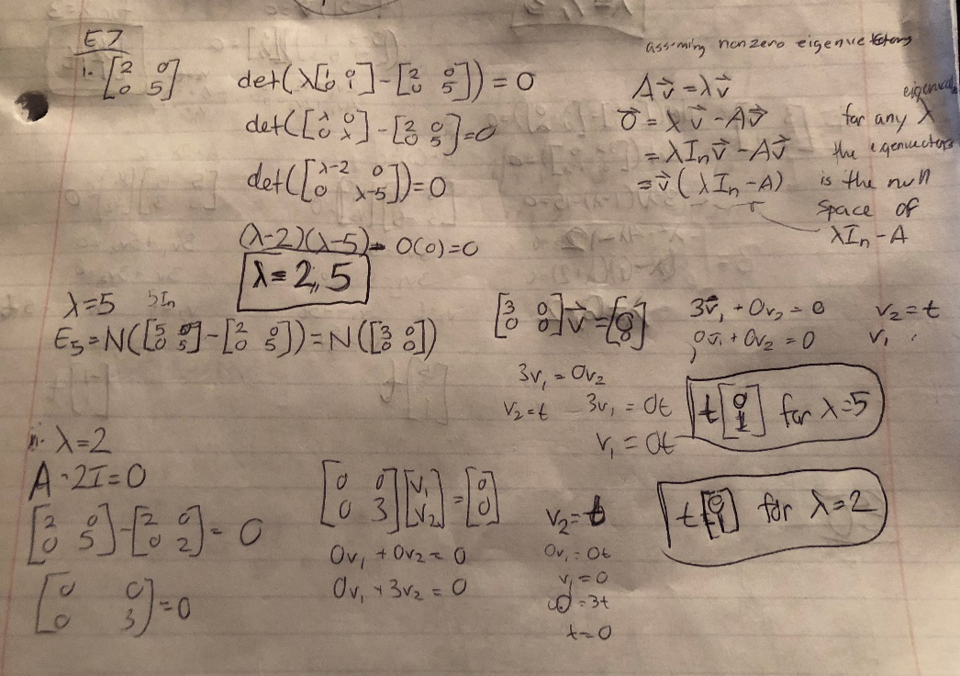

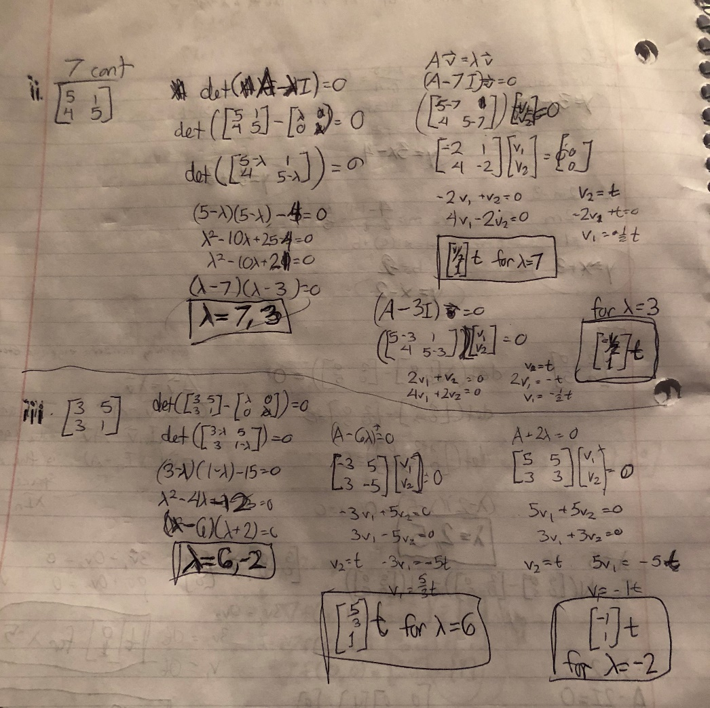

**E.8:**

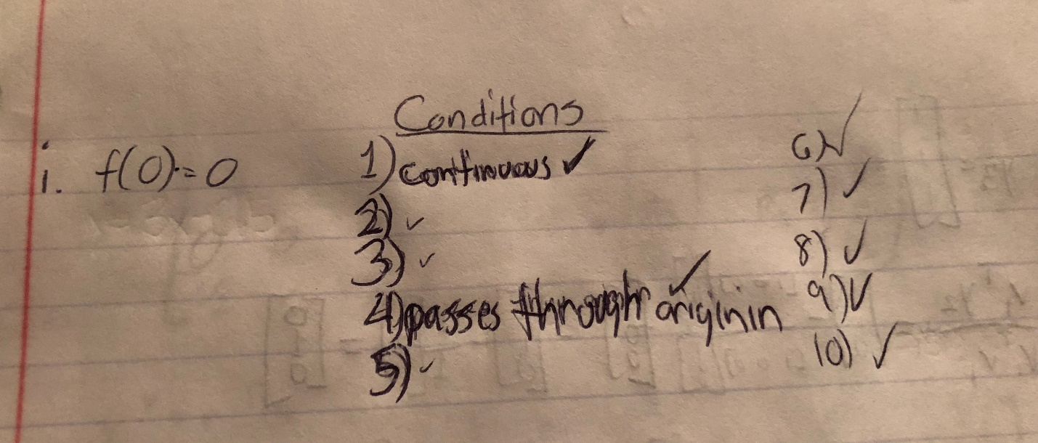

**E.9: Which of the following sets of vectors are independent? Find the dimension of the vector space spanned by each set. (Verify your answers using Python).**

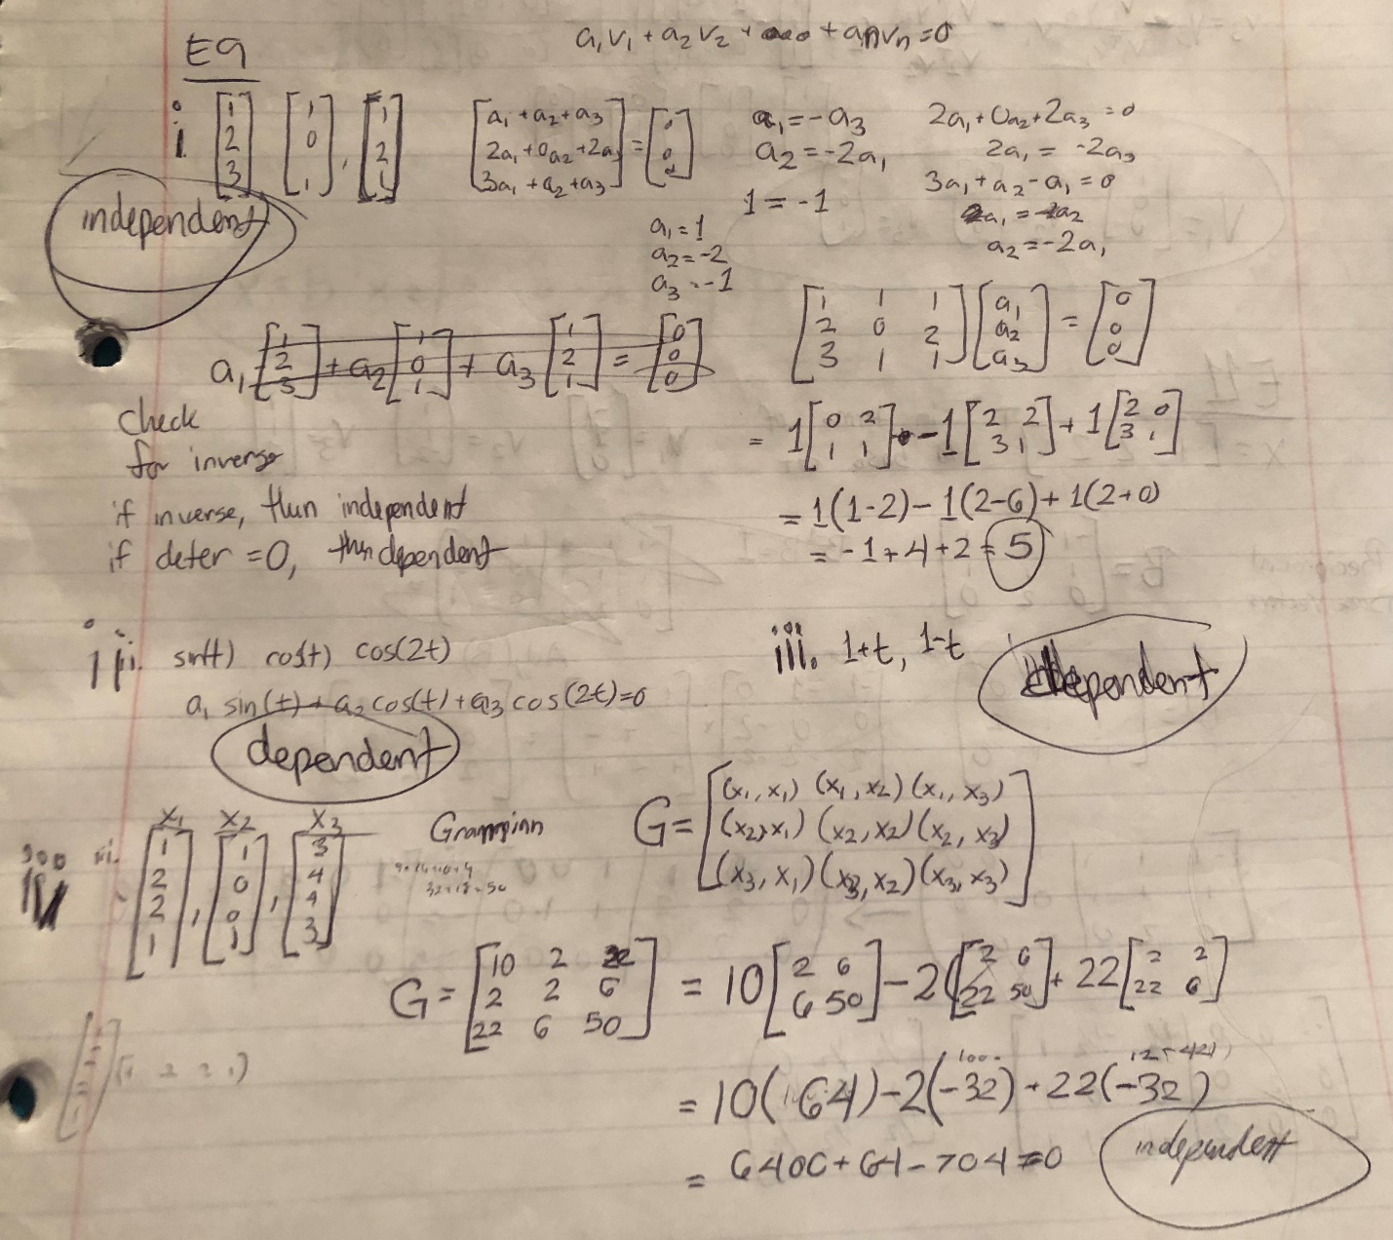

**E.10: Using the following basis vectors, ﬁnd an orthogonal set using Gram-Schmidt orthogonalization.**

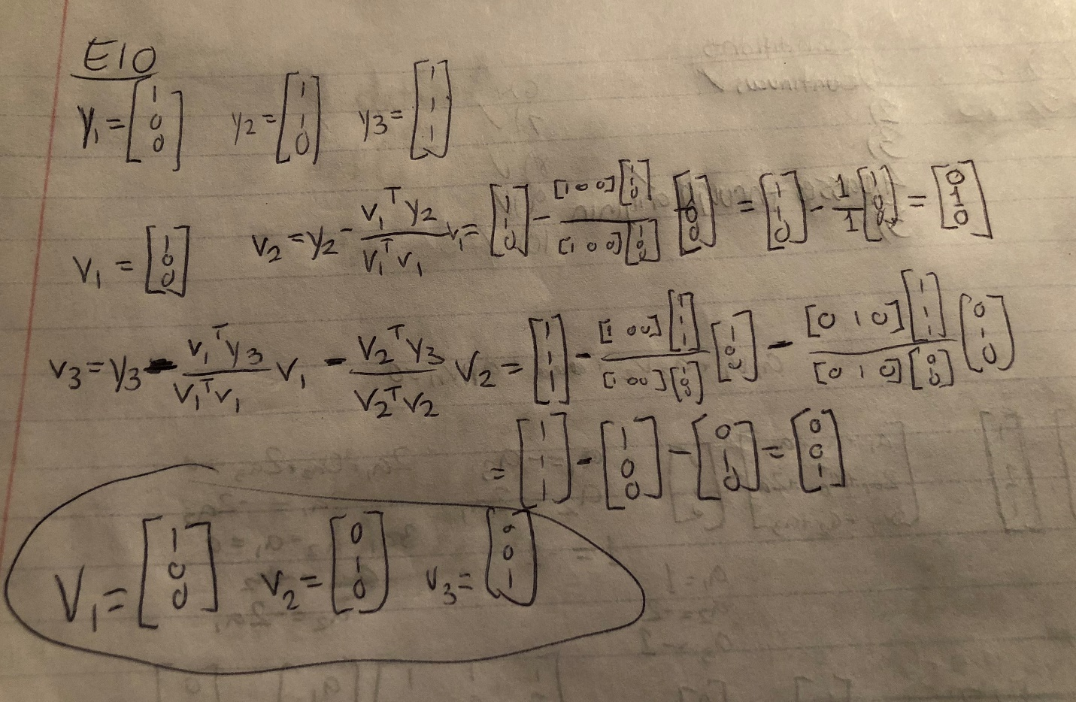

**E.11: Expand x = [1 2 2 ]T in terms of the following basis set.**

